**Industrial Visit**

**2023-2024**

Bangalore

# Expected Budget/person at count of 55 person.

6000/-

# Industry

# Herkey.LTD

# Route

Kudal -> Madgaon …time:2.5Hr,

Madgaon>Yeshwantpur(Bangalore)time:13Hr.

* **Spots**

Isckon Temple,

Science Museum,

MYSORE Trip [Mysore palace, Mysore spots, Snow World],

Cubben Park [Aquarium, temple ,heritage site ]

Bangalore Palace,

Film City

Banner cutta(zoo)

* **Stay**

Hotel Habitat Comfort (3STAR)

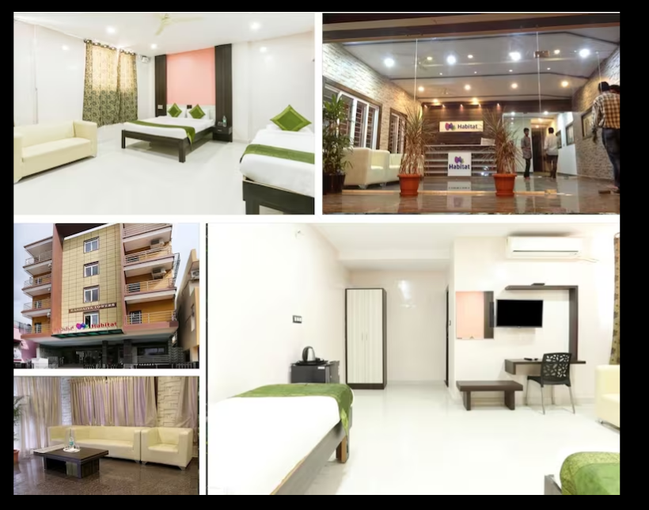

# Local Travelling

AC Bus (Tejas Travels)

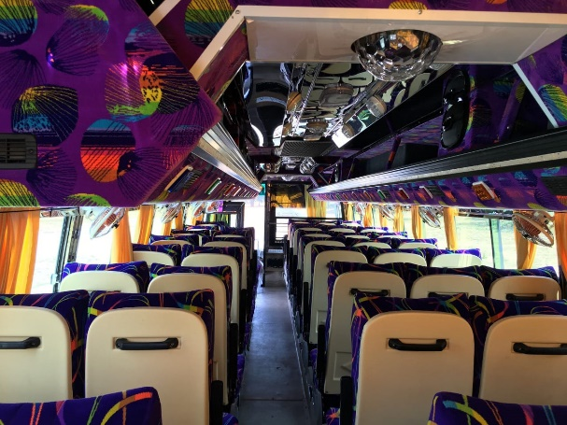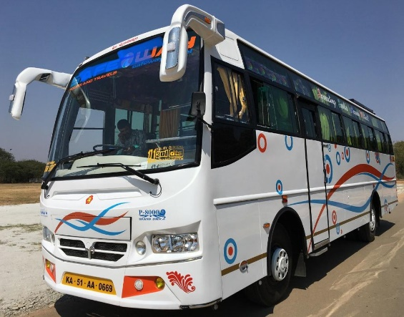

# Journey date Jan 30,31 feb 1,2,3,4,5 7 Days

ROUTES CONNECTIVITY

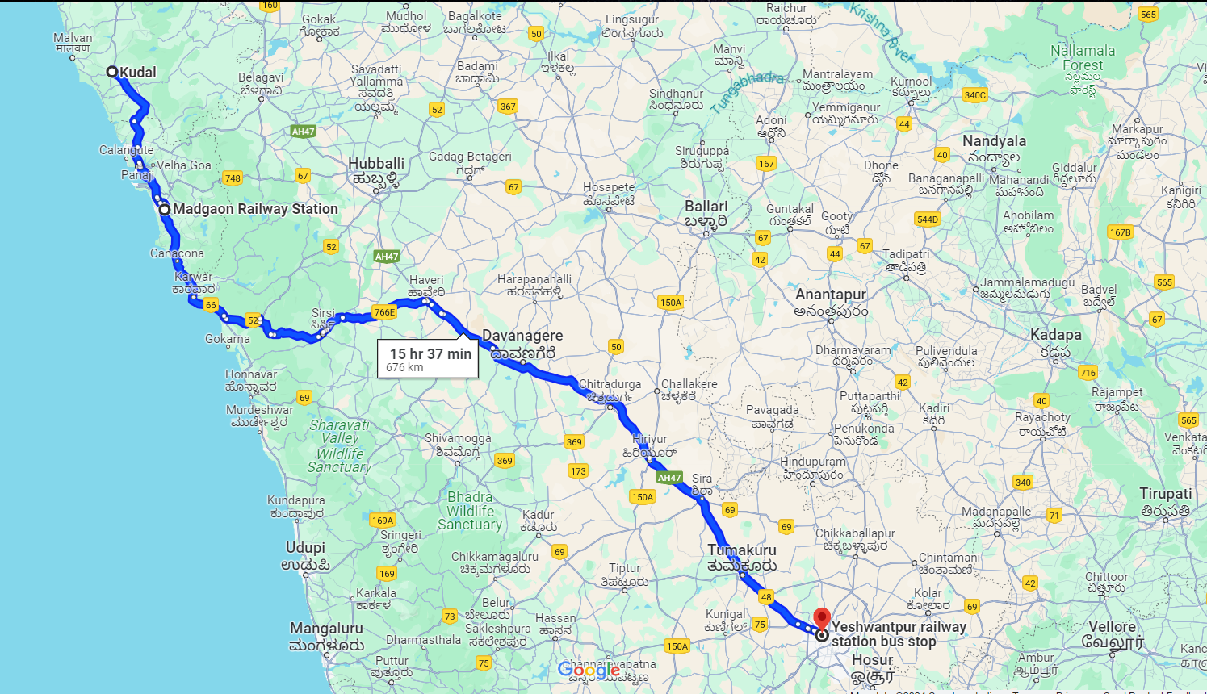

* TOWORDS KUDAL 🡪MADGAON

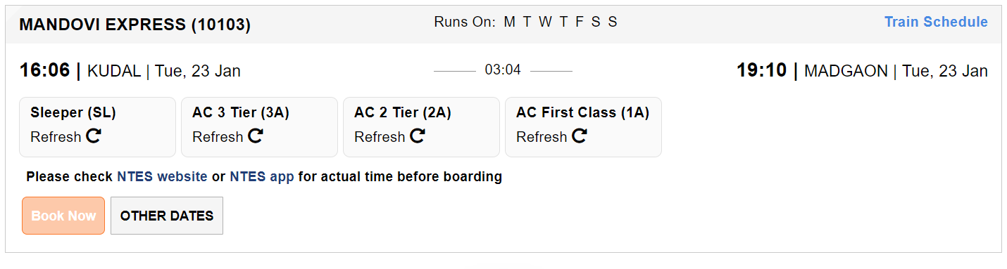

* TOWORDS MADGAON -> YESHWANTPUR

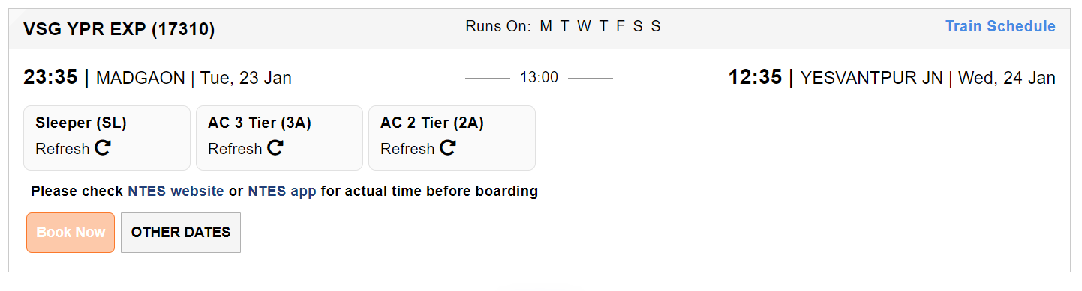

* TOWARDS YESHWANTPUR->MADGAON

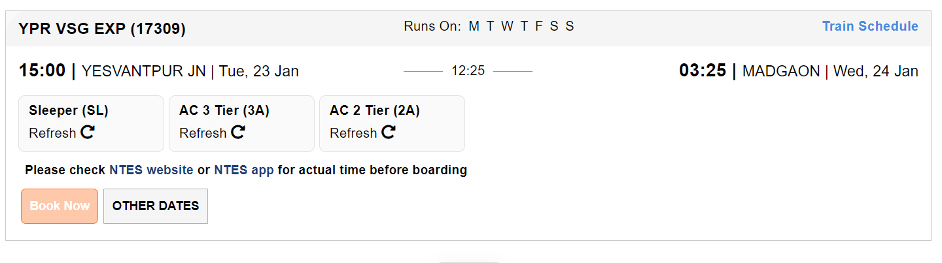

* TOWARDS MADGAON-->KUDAL
* 